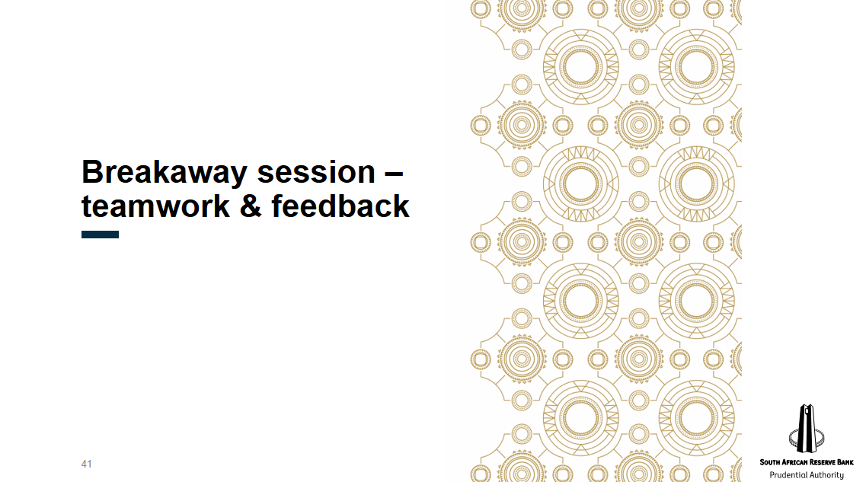
Case Study Part 1: BOPHELO LIFE ASSURANCE PROVIDERS Ltd. (BLAP)
45 min

You are the supervisory manager in the Insurance Supervision department of the Prudential Supervisory Authority (the PSA) in your country ABC Republic. ABC Republic has seen a decline in its mining and construction sectors in recent years, which has contributed to low economic growth. ABC Republic operates a risk-based financial sector supervision framework. As part of your role, you manage a team that supervises a portfolio of small to medium-sized insurers including Bophelo Life Assurance Providers Ltd. (BLAP)
BLAP is a medium sized life Insurance company licensed in ABC Republic. It writes mostly funeral business through schemes. BLAP’s main distribution channels are specialist funeral underwriting managers, including family-owned funeral homes. BLAP was founded by Mr Hughes, who now owns 12 percent of its shares. Mr Hughes is a well-known entrepreneur, who also has controlling interests in companies in the mining sector. Mr Hughes has long been active in the political process, providing significant financial contributions, assisting in the recruitment of candidates and offering input on policy. Through this involvement, Mr Hughes has become a personal friend of many politicians, including the Minister of Finance. Ownership of the remaining shares of BLAP are split as follows:
- 13% owned by Mr Hughes’ daughter, Ms Junior
- 20% owned by two local businesspersons and long-time friends of Mr Hughes: Mr Ross and Mr Mkize, who are active in the mining and construction sectors.
- 45% Owned by collective investment scheme that is owned by a locally registered large insurance group
- 10% owned by an Equity investment consortium
Mr Hughes is a non-executive director in BLAP and has previously communicated to your team that he does not influence the operations of BLAP. Following her completion of an MBA, Ms. Junior was appointed as the CEO of BLAP.
In recent years, BLAP has experienced an increase in policy lapses as the economic growth in ABC Republic has stalled. This has led to declines in premium and assets. In recent supervisory visits BLAP has outlined a plan to venture into different lines of business – including whole of life cover in order to boost business growth.

Case Study Part 2: GenCo Insurance Group (GenCo)
45 min

GenCo Insurance Group PLC (GenCo) is a global composite insurance group that offers insurance, investment, financial planning, and retirement advice. The group is headquartered in the United States of America. GenCo conducted a market feasibility study for ABC Republic and concluded that it is a lucrative jurisdiction for conducting insurance due to low insurance penetration levels. GenCo has taken a keen interest in BLAP’s potential for growth and hence is applying to the PSA to be the sole shareholder of BLAP (owning 100% of the shares in BLAP). GenCo also intends to establish a new general insurer – Bophelo Insurance Providers (BIP) writing property and liability risks.
Based on a meeting your team held with GenCo at their request, you have summarized their plans as follows:
Purchase of BLAP:
GenCo has established a holding company in ABC Republic that is intended to own 100% of the shares in both BLAP and BIP. Through this holding company GenCo is negotiating a share purchase agreement with the current shareholders of BLAP. The sale is planned for R50 million.
To establish the non-life Insurer, BIP, Genco understands that insurers need adequate capital to manage the business and promises to inject capital into BIP in the following manner:
- R 5 million share capital in year 1;
- R 6 million share capital in year 2;
- R 7 million share capital in year 3; and
- R 10 million share capial in year 4
Governance:
Because BLAP is medium sized, GenCo is comfortable that in the interim, BLAP’s board will comprise of GenCo’s board members, and plans to appoint new board members who are domiciled in ABC Republic, in the next 5 years. GenCo has begun recruiting board members to serve on the BIP board.
GenCo plans to outsource all of BLAP’s and BIP’s control functions to GenCo in the USA in an effort to cut down operational costs.
Licence Strategy:
GenCo is satisfied with BLAP’s life insurance product features and plans to scale by using other different distribution channels in ABC Republic and investing in IT systems.
For the non-life business, GenCo has noted the low insurance penetration rate for property flood cover in the low-income sectors of ABC Republic. In response GenCo intends to use the BIP licence to offer innovative parametric solutions in the Republic as a nice flood insurer.
GenCo has also ascertained that BLAP’s ‘own funds’ will be invested solely in cash and deposits and will be deposited in a reputable commercial bank in ABC Republic.

